**19-06-2025-Coding Challenge SQL**

CREATE DATABASE car_rental_system;

USE car_rental_system;

CREATE TABLE Vehicle (vehicleID INT PRIMARY KEY,make VARCHAR(50),model VARCHAR(50),year YEAR,dailyRate DECIMAL(10,2),status ENUM('available', 'notAvailable'),passengerCapacity INT, engineCapacity INT);

CREATE TABLE Customer (customerID INT PRIMARY KEY,firstName VARCHAR(50),lastName VARCHAR(50), email VARCHAR(100),phoneNumber VARCHAR(20));

CREATE TABLE Lease (leaseID INT PRIMARY KEY,vehicleID INT,customerID INT,startDate DATE,endDate DATE, type ENUM('Daily','Monthly'),FOREIGN KEY (vehicleID) REFERENCES Vehicle(vehicleID),FOREIGN KEY (customerID) REFERENCES Customer(customerID));

CREATE TABLE Payment (paymentID INT PRIMARY KEY,leaseID INT,paymentDate DATE,amount DECIMAL(10,2),FOREIGN KEY (leaseID) REFERENCES Lease(leaseID));

INSERT INTO Vehicle VALUES

(1, 'Toyota', 'Camry', 2022, 50.00, 'available', 4, 1450),

(2, 'Honda', 'Civic', 2023, 45.00, 'available', 7, 1500),

(3, 'Ford', 'Focus', 2022, 48.00, 'notAvailable', 4, 1400),

(4, 'Nissan', 'Altima', 2023, 52.00, 'available', 7, 1200),

(5, 'Chevrolet', 'Malibu', 2022, 47.00, 'available', 4, 1800),

(6, 'Hyundai', 'Sonata', 2023, 49.00, 'notAvailable', 7, 1400),

(7, 'BMW', '3 Series', 2023, 60.00, 'available', 7, 2499),

(8, 'Mercedes', 'C-Class', 2022, 58.00, 'available', 8, 2599),

(9, 'Audi', 'A4', 2022, 55.00, 'notAvailable', 4, 2500),

(10, 'Lexus', 'ES', 2023, 54.00, 'available', 4, 2500);

INSERT INTO Customer VALUES

(1, 'John', 'Doe', 'johndoe@example.com', '555-555-5555'),

(2, 'Jane', 'Smith', 'janesmith@example.com', '555-123-4567'),

(3, 'Robert', 'Johnson', 'robert@example.com', '555-789-1234'),

(4, 'Sarah', 'Brown', 'sarah@example.com', '555-456-7890'),

(5, 'David', 'Lee', 'david@example.com', '555-987-6543'),

(6, 'Laura', 'Hall', 'laura@example.com', '555-234-5678'),

(7, 'Michael', 'Davis', 'michael@example.com', '555-876-5432'),

(8, 'Emma', 'Wilson', 'emma@example.com', '555-432-1098'),

(9, 'William', 'Taylor', 'william@example.com', '555-321-6547'),

(10, 'Olivia', 'Adams', 'olivia@example.com', '555-765-4321');

INSERT INTO Lease VALUES

(1, 1, 1, '2023-01-01', '2023-01-05', 'Daily'),

(2, 2, 2, '2023-02-15', '2023-02-28', 'Monthly'),

(3, 3, 3, '2023-03-10', '2023-03-15', 'Daily'),

(4, 4, 4, '2023-04-20', '2023-04-30', 'Monthly'),

(5, 5, 5, '2023-05-05', '2023-05-10', 'Daily'),

(6, 4, 3, '2025-06-15', '2025-06-25', 'Monthly'),

(7, 7, 7, '2025-07-01', '2025-07-10', 'Daily'),

(8, 8, 8, '2025-08-12', '2025-06-19', 'Monthly'),

(9, 3, 3, '2025-09-07', '2025-09-10', 'Daily'),

(10, 10, 10, '2025-10-10', '2025-10-31', 'Monthly');

INSERT INTO Payment VALUES

(1, 1, '2023-01-03', 200.00),

(2, 2, '2023-02-20', 1000.00),

(3, 3, '2023-03-12', 75.00),

(4, 4, '2023-04-25', 900.00),

(5, 5, '2023-05-07', 60.00),

(6, 6, '2025-06-18', 1200.00),

(7, 7, '2025-07-03', 40.00),

(8, 8, '2025-08-14', 1100.00),

(9, 9, '2025-09-09', 80.00),

(10, 10, '2025-10-25', 1500.00);

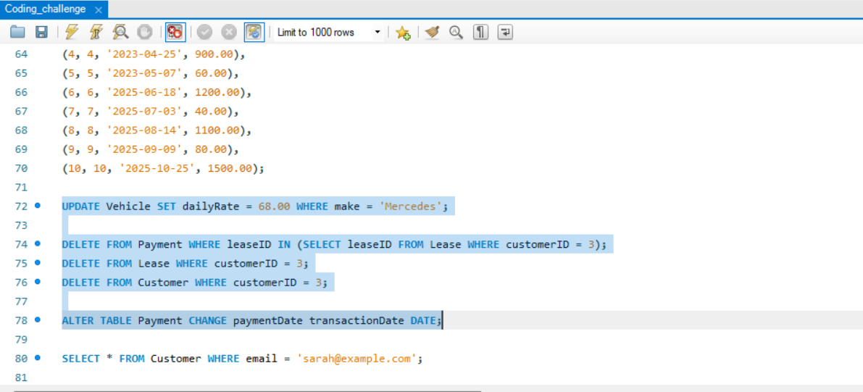

1. **Update the daily rate for a Mercedes car to 68.**

UPDATE Vehicle SET dailyRate = 68.00 WHERE make = 'Mercedes';

1. **Delete a specific customer and all associated leases and payments**.

DELETE FROM Payment WHERE leaseID IN (SELECT leaseID FROM Lease WHERE customerID = 3);

DELETE FROM Lease WHERE customerID = 3;

DELETE FROM Customer WHERE customerID = 3;

1. **Rename the "paymentDate" column in the Payment table to "transactionDate".**

ALTER TABLE Payment CHANGE payment Date transactionDate DATE;

1. **Find a specific customer by email.**

SELECT * FROM Customer WHERE email = 'sarah@example.com';

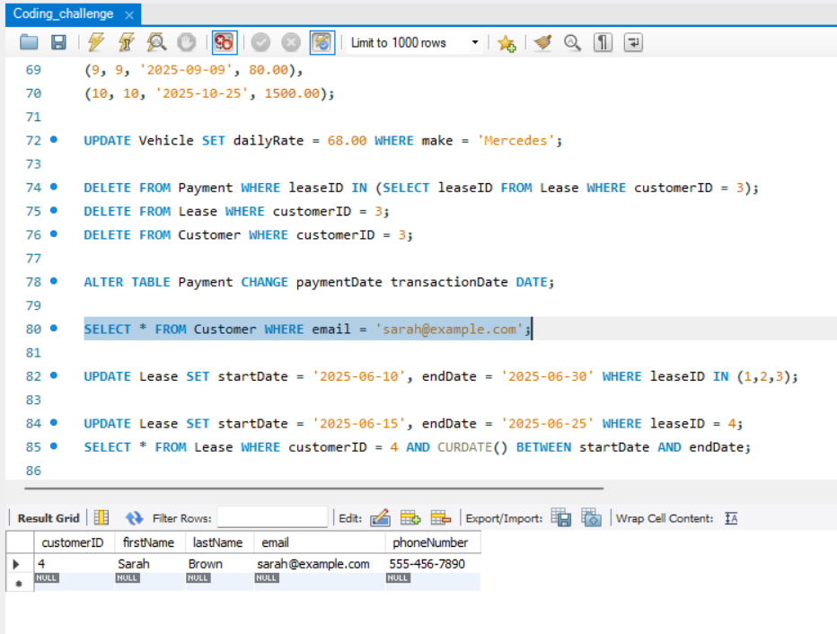

1. **Get active leases for a specific customer.**

UPDATE Lease SET startDate = '2025-06-10', endDate = '2025-06-30' WHERE leaseID IN (1,2,3);

UPDATE Lease SET startDate = '2025-06-15', endDate = '2025-06-25' WHERE leaseID = 4;

SELECT * FROM Lease WHERE customerID = 4 AND CURDATE() BETWEEN startDate AND endDate;

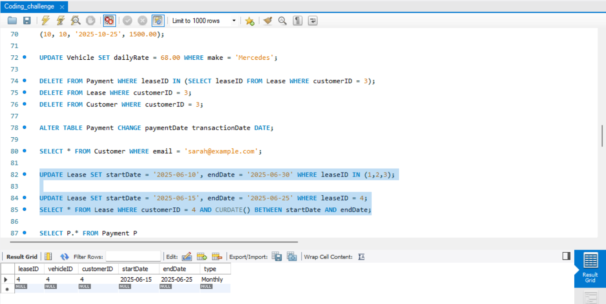

1. **Find all payments made by a customer with a specific phone number.**

SELECT P.* FROM Payment P

JOIN Lease L ON P.leaseID = L.leaseID

JOIN Customer C ON L.customerID = C.customerID

WHERE C.phoneNumber = '555-123-4567';

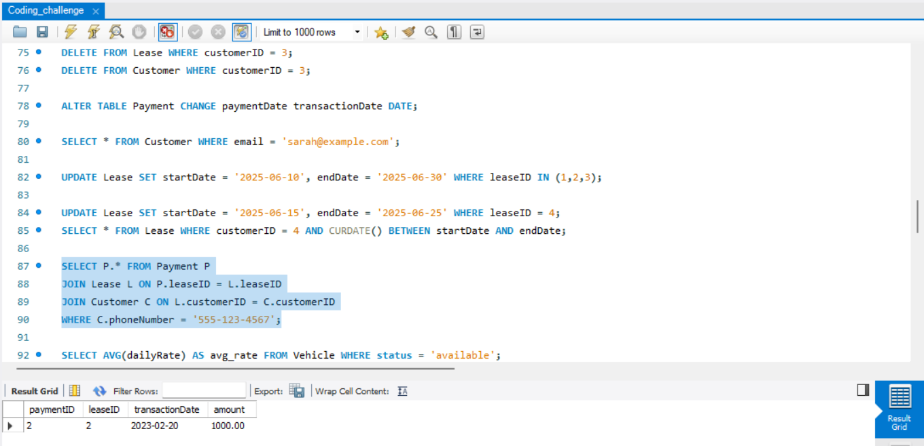

1. **Calculate the average daily rate of all available cars.**

SELECT AVG(dailyRate) AS avg_rate FROM Vehicle WHERE status = 'available';

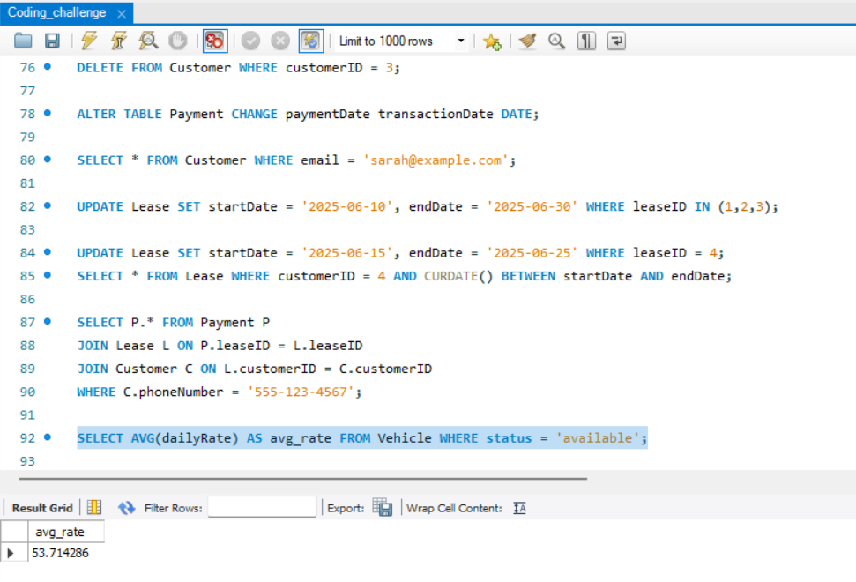

1. **Find the car with the highest daily rate.**

SELECT * FROM Vehicle WHERE dailyRate = (SELECT MAX(dailyRate) FROM Vehicle);

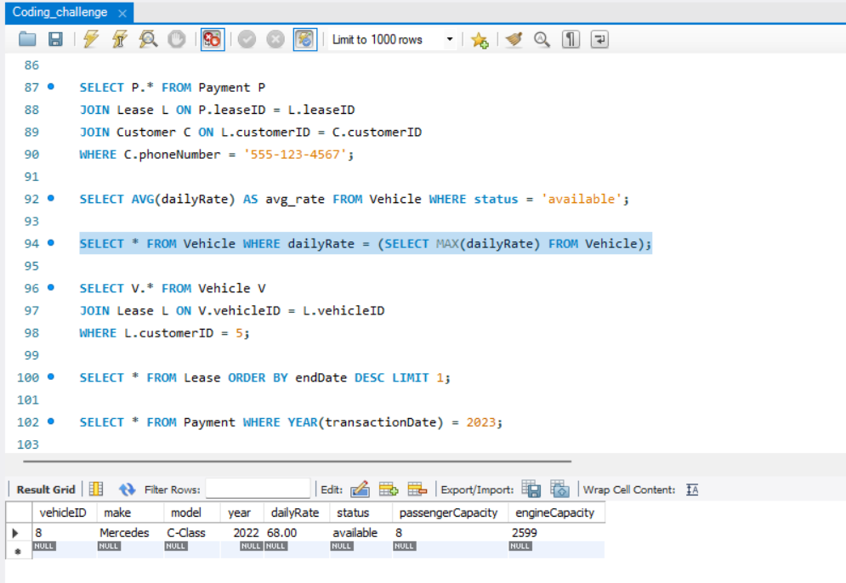

1. **Retrieve all cars leased by a specific customer.**

SELECT V.* FROM Vehicle V

JOIN Lease L ON V.vehicleID = L.vehicleID

WHERE L.customerID = 5;

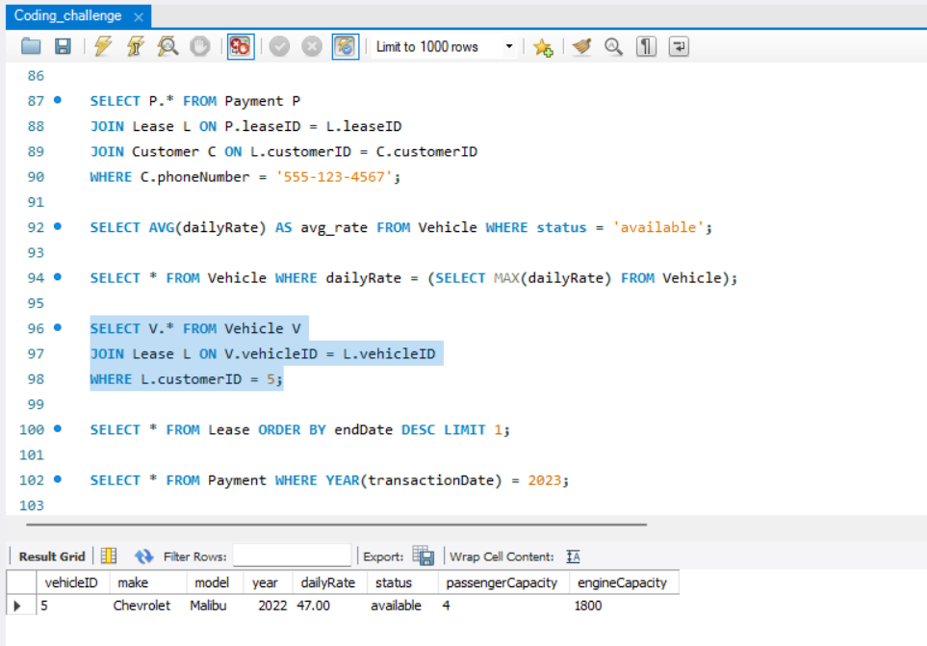

1. **Find the details of the most recent lease.**

SELECT * FROM Lease ORDER BY endDate DESC LIMIT 1;

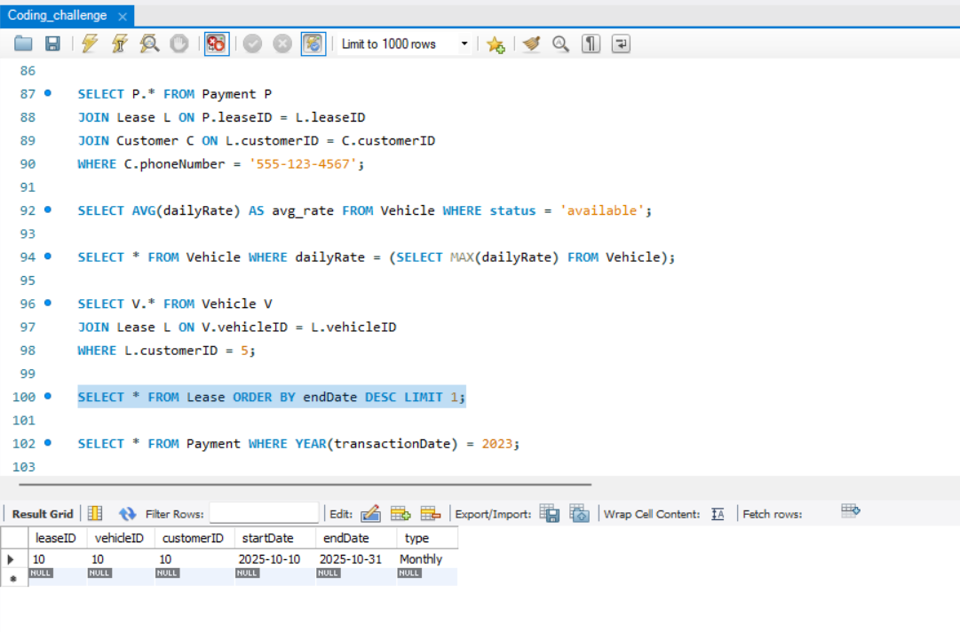

1. **List all payments made in the year 2023.**

SELECT * FROM Payment WHERE YEAR(transactionDate) = 2023;

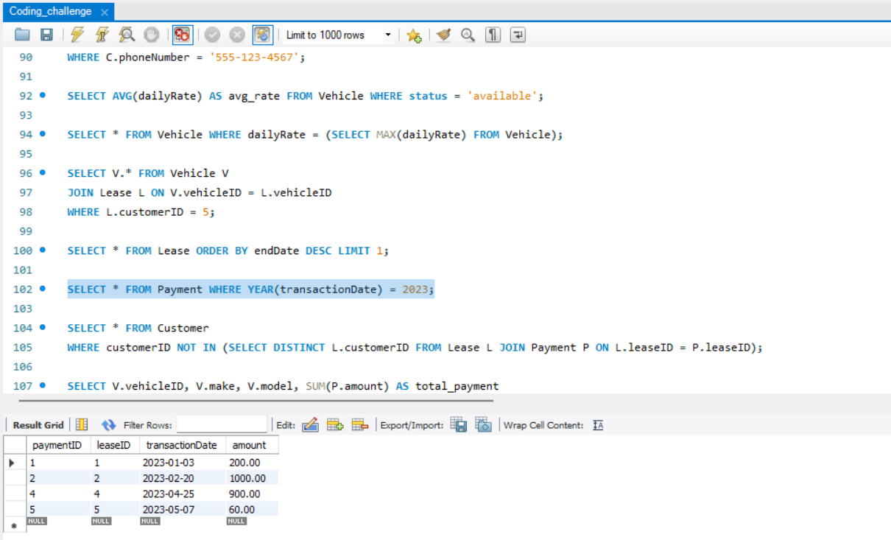

1. **Retrieve customers who have not made any payments.**

SELECT * FROM Customer

WHERE customerID NOT IN (SELECT DISTINCT L.customerID

FROM Lease L JOIN Payment P ON L.leaseID = P.leaseID);

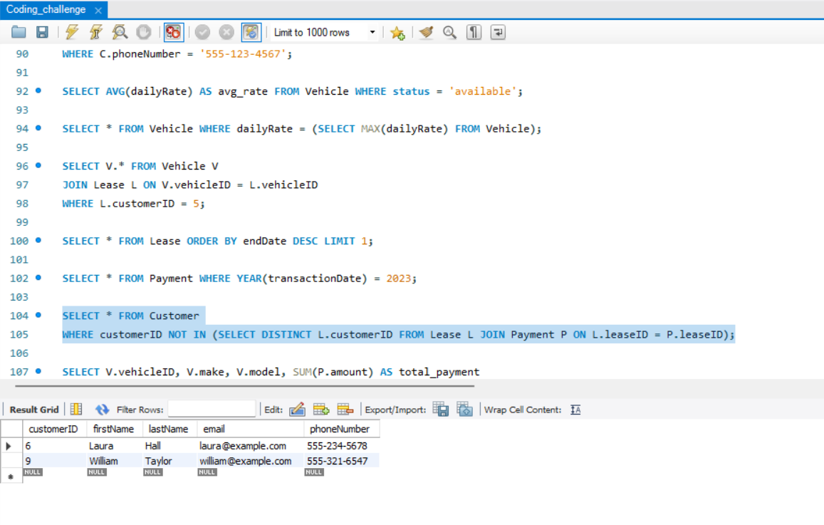

1. **Retrieve Car Details and Their Total Payments.**

SELECT V.vehicleID, V.make, V.model, SUM(P.amount) AS total_payment

FROM Vehicle V

JOIN Lease L ON V.vehicleID = L.vehicleID

JOIN Payment P ON L.leaseID = P.leaseID

GROUP BY V.vehicleID;

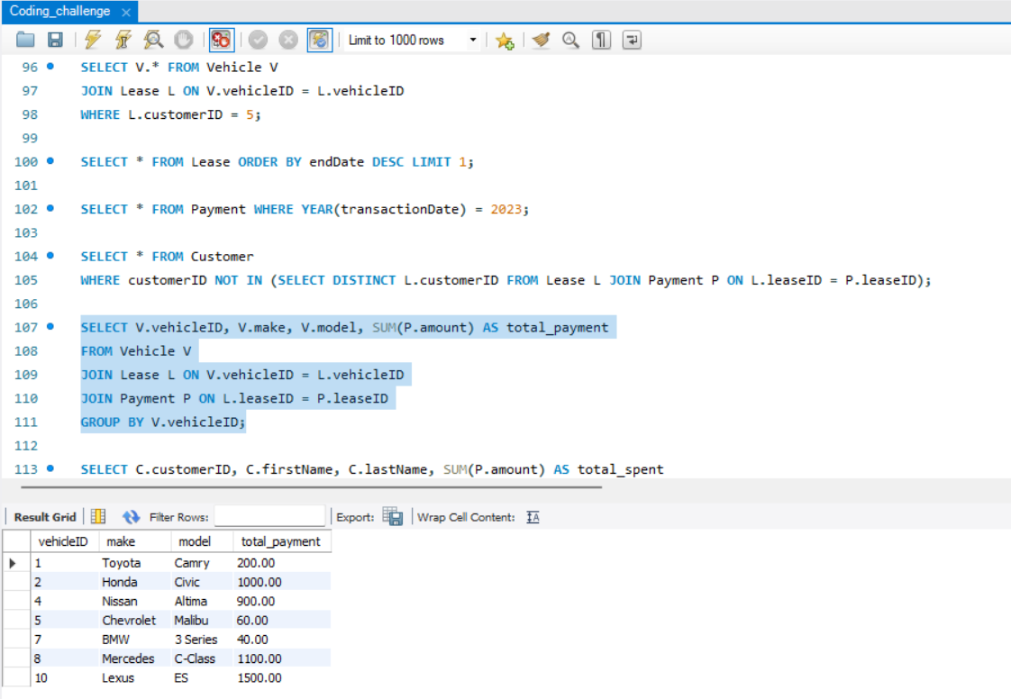

1. **Calculate Total Payments for Each Customer.**

SELECT C.customerID, C.firstName, C.lastName, SUM(P.amount) AS total_spent

FROM Customer C

JOIN Lease L ON C.customerID = L.customerID

JOIN Payment P ON L.leaseID = P.leaseID

GROUP BY C.customerID;

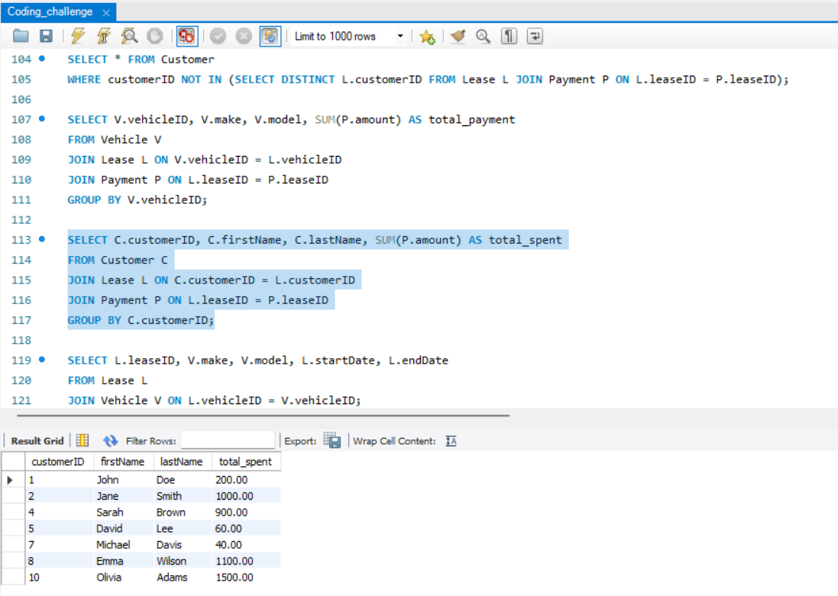

1. **List Car Details for Each Lease.**

SELECT L.leaseID, V.make, V.model, L.startDate, L.endDate

FROM Lease L

JOIN Vehicle V ON L.vehicleID = V.vehicleID;

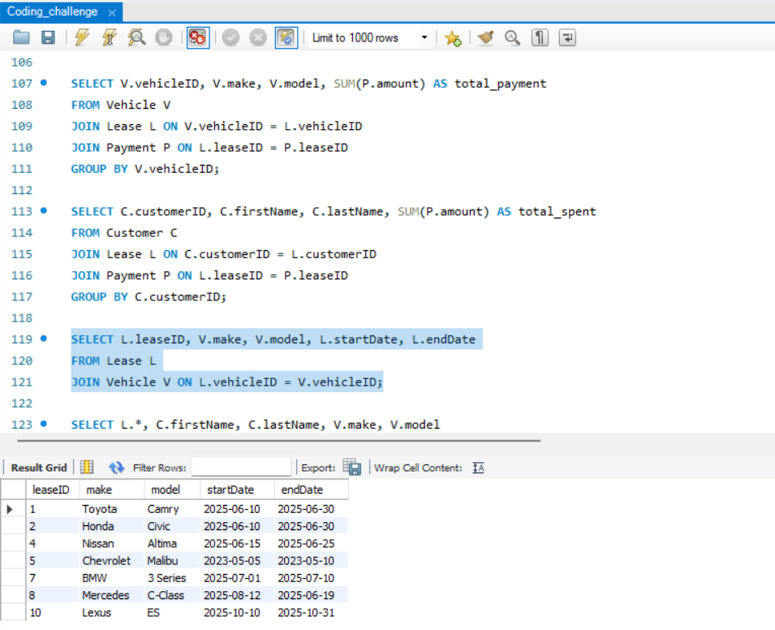

1. **Retrieve Details of Active Leases with Customer and Car Information.**

SELECT L.*, C.firstName, C.lastName, V.make, V.model

FROM Lease L

JOIN Customer C ON L.customerID = C.customerID

JOIN Vehicle V ON L.vehicleID = V.vehicleID

WHERE CURDATE() BETWEEN L.startDate AND L.endDate;

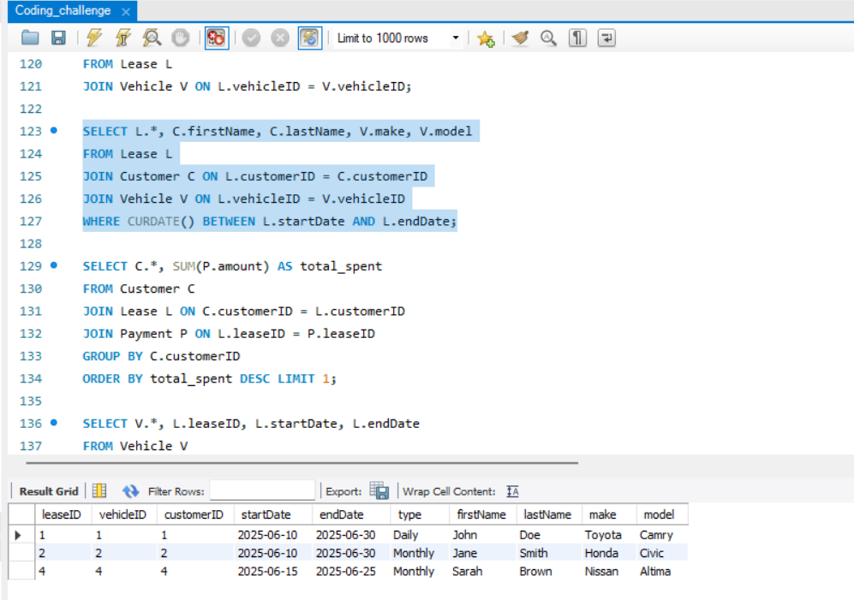

**17. Find the Customer Who Has Spent the Most on Leases.**

SELECT C.*, SUM(P.amount) AS total_spent

FROM Customer C

JOIN Lease L ON C.customerID = L.customerID

JOIN Payment P ON L.leaseID = P.leaseID

GROUP BY C.customerID

ORDER BY total_spent DESC LIMIT 1;

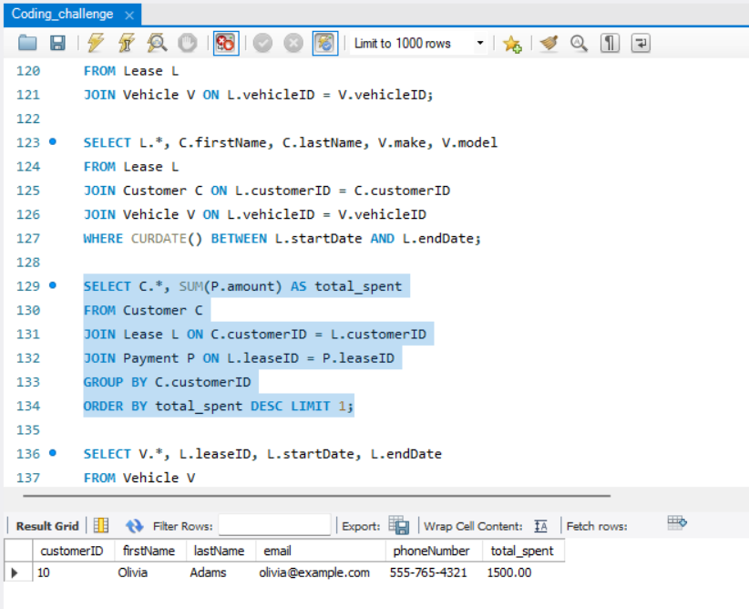

**18. List All Cars with Their Current Lease Information.**

SELECT V.*, L.leaseID, L.startDate, L.endDate

FROM Vehicle V

LEFT JOIN Lease L ON V.vehicleID = L.vehicleID

AND CURDATE() BETWEEN L.startDate AND L.endDate;

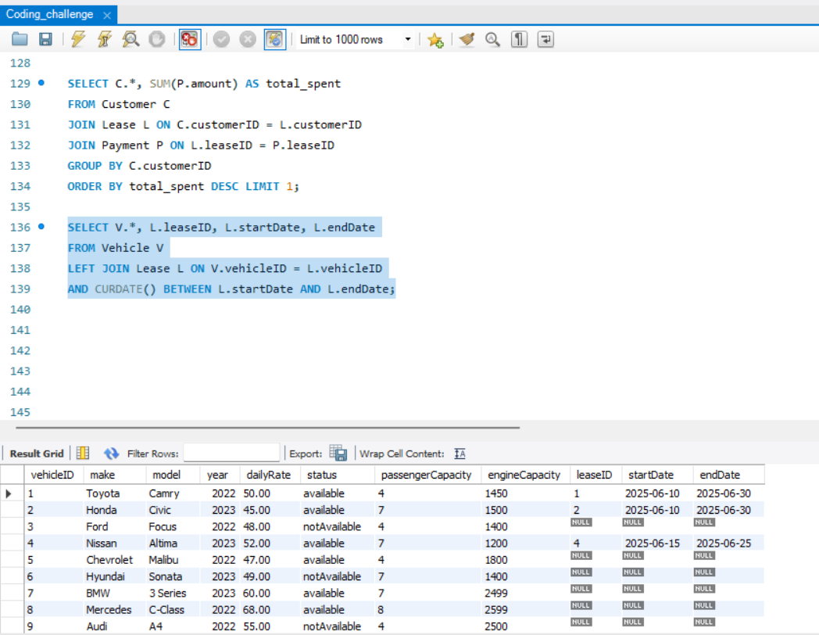

**Submitted By: SIVA BALAN T**